22. TWO BIT HALF SUBTRACTOR

EXP.NO: 22

AIM: To design and implement the two bit half subtractor using Logisim simulator.

PROCEDURE:

1)      Pick and place the necessary gates.

2)      Insert 2 inputs into the canvas.

3)      Connect the inputs to the OR gate, AND gate and NOT gate.

4)      Insert 2 outputs into the canvas.

5)      Make the connections using the connecting wires.

6)      Verify the truth table.

TRUTH TABLE:

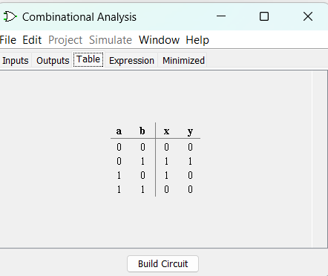

Diff=A&#39;B+AB&#39;

Borrow = A&#39;B

Logical Diagram:

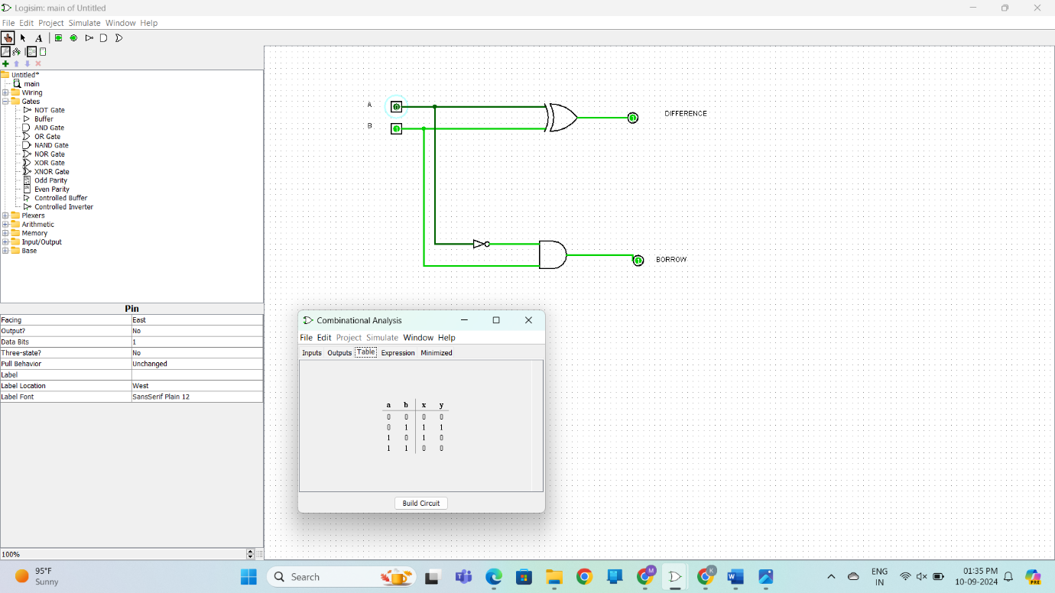

Half Subtractor using NAND Gates OUTPUT:

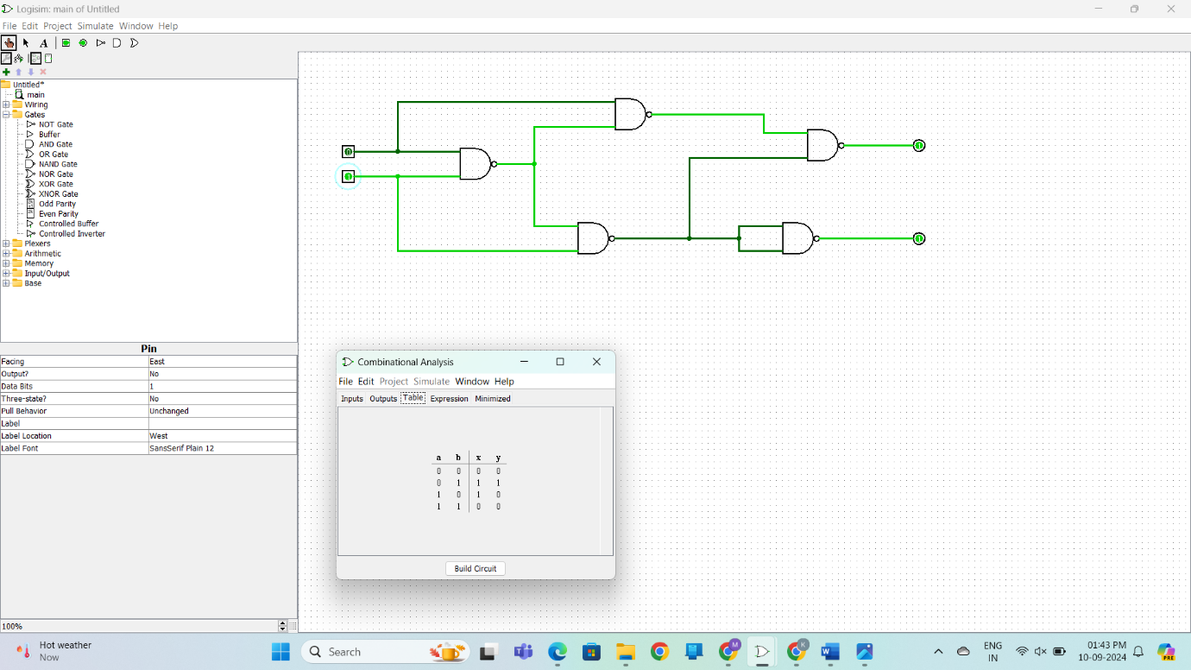

Half Subtractor using NOR Gates OUTPUT:

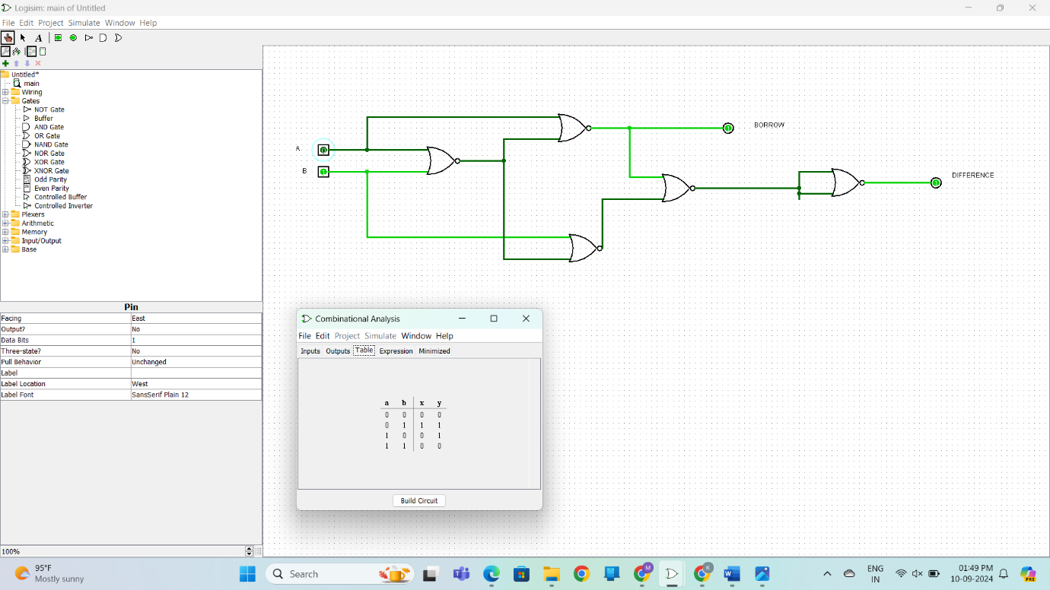

RESULT: Thus 2-bit half subtractor has been designed and implemented successfully using

logisim simulator.